**HIVE - II**

**Student Name: Nabh Sanjay Mehta Student Id: NSM190002**

**Date: 02/25/2020**

Step-1: Open the terminal application on the Cloudera VM desktop.

Q. Take a screenshot of the terminal application and paste it below.

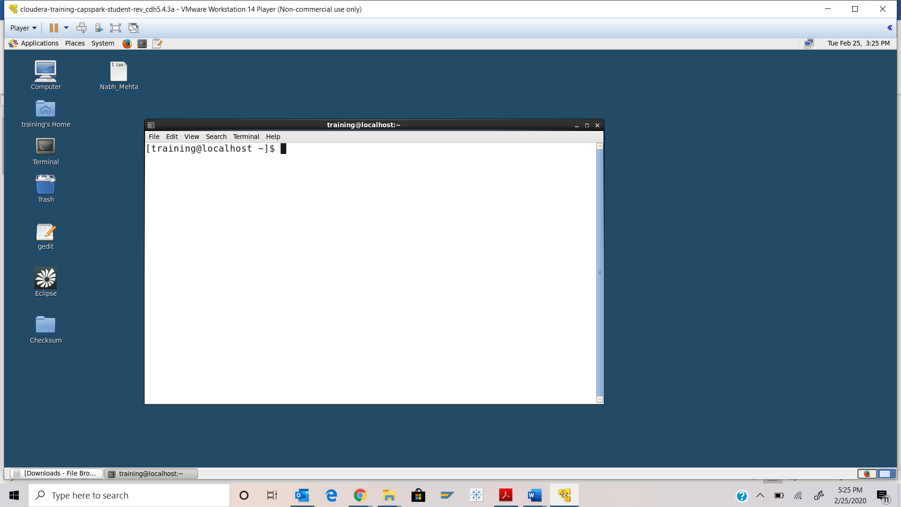

Step-2: Execute the following commands at the shell prompt:



Q. Take a screenshot of the shell output paste it below.

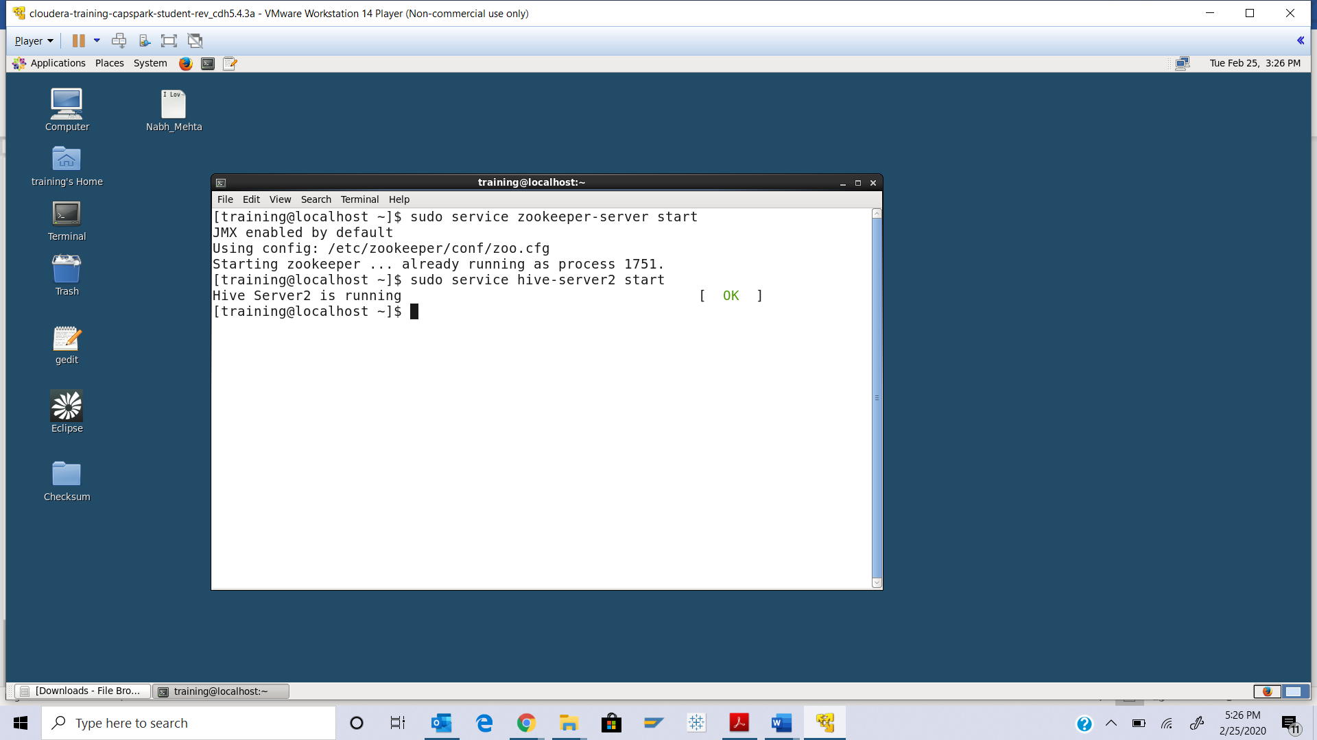

Step-3: Execute the following command at the shell prompt:





Q. Execute the command at the shell prompt, take a screenshot of the shell output and paste it below.

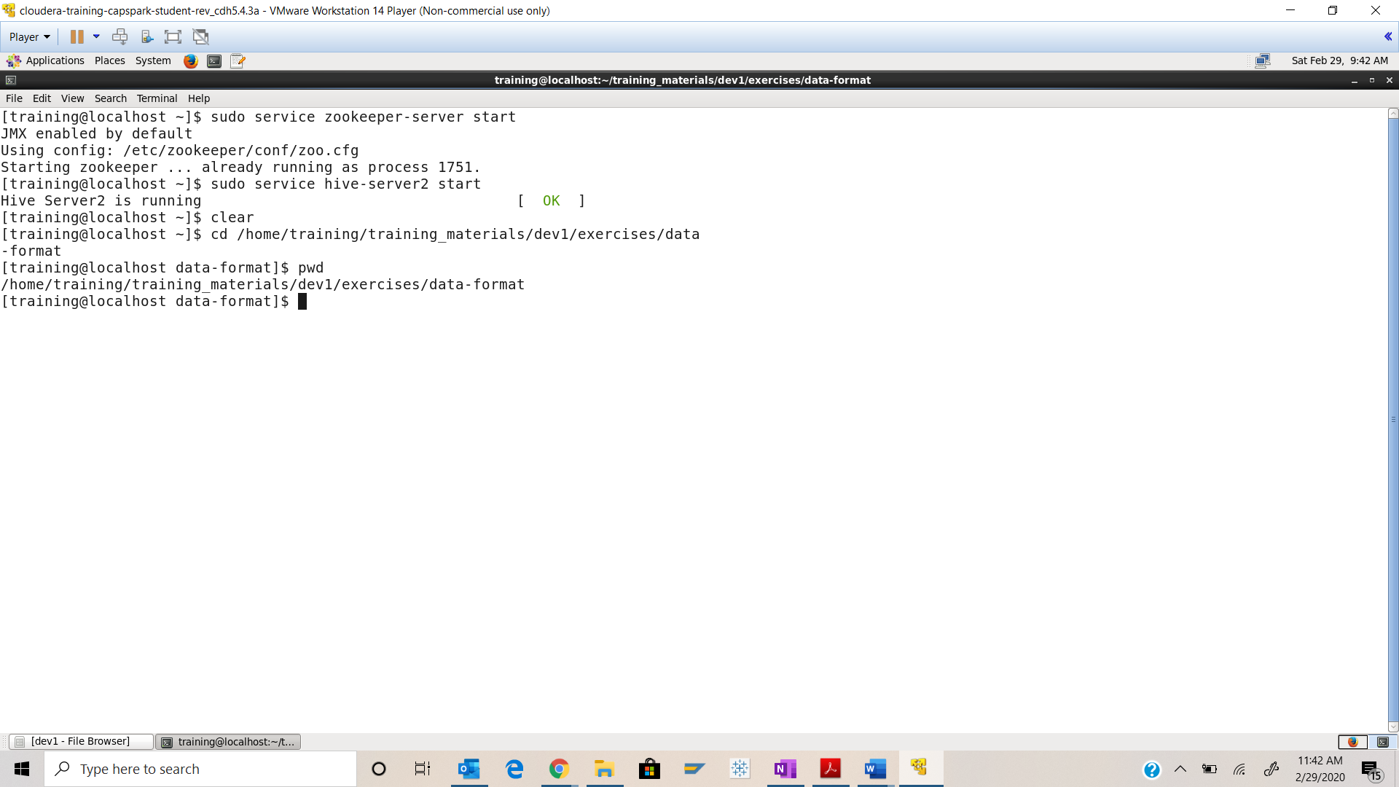

Step-4: Execute the following command at the shell prompt:

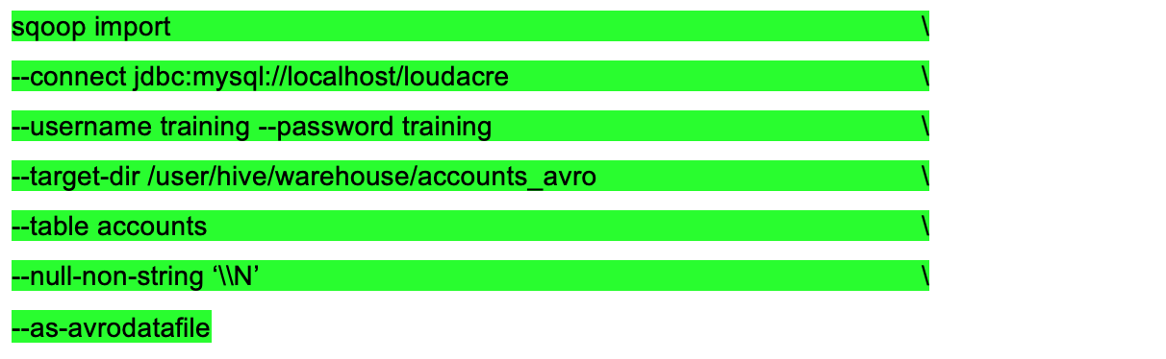

Q. Take a screenshot of the shell output and paste it below.

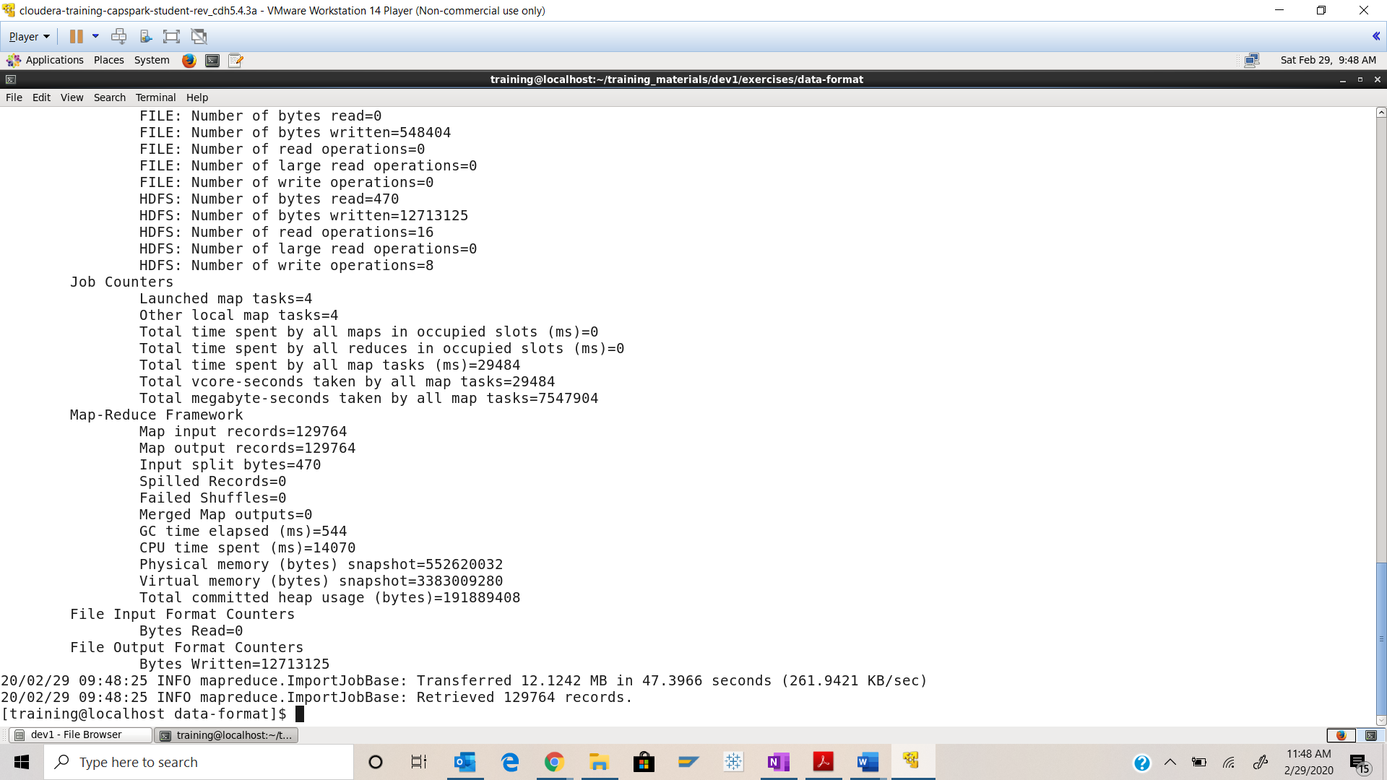

Step-5: Open the Firefox browser and start the HUE file browser. Navigate to the following directory /user/hive/warehouse/accounts_avro.

Q. Open any of the files in this directory. Take a screenshot of the file contents and paste it below. What kind of format is the data stored in?

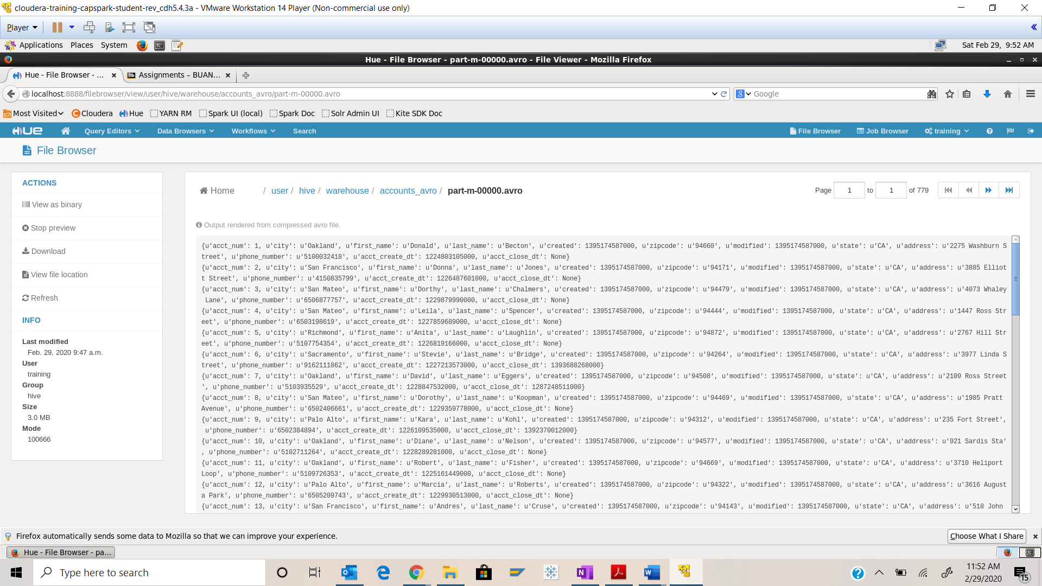

This is an Avro file which stores data in .JSON format

Step-6: Switch back to the terminal application and execute the following command at the shell prompt:



Q. Take a screenshot of the shell output and paste it below.

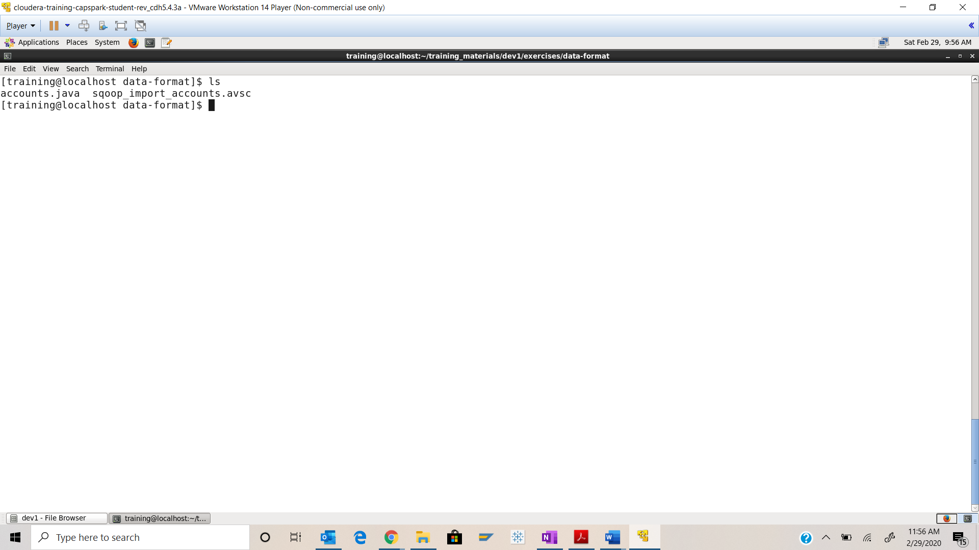Step-7: Execute the following command at the shell prompt:



Q. Using the file browser in HUE, navigate to the /user/hive/warehouse directory, take a screenshot of the contents and paste it below. Highlight the sqoop_import_accounts.avsc file.

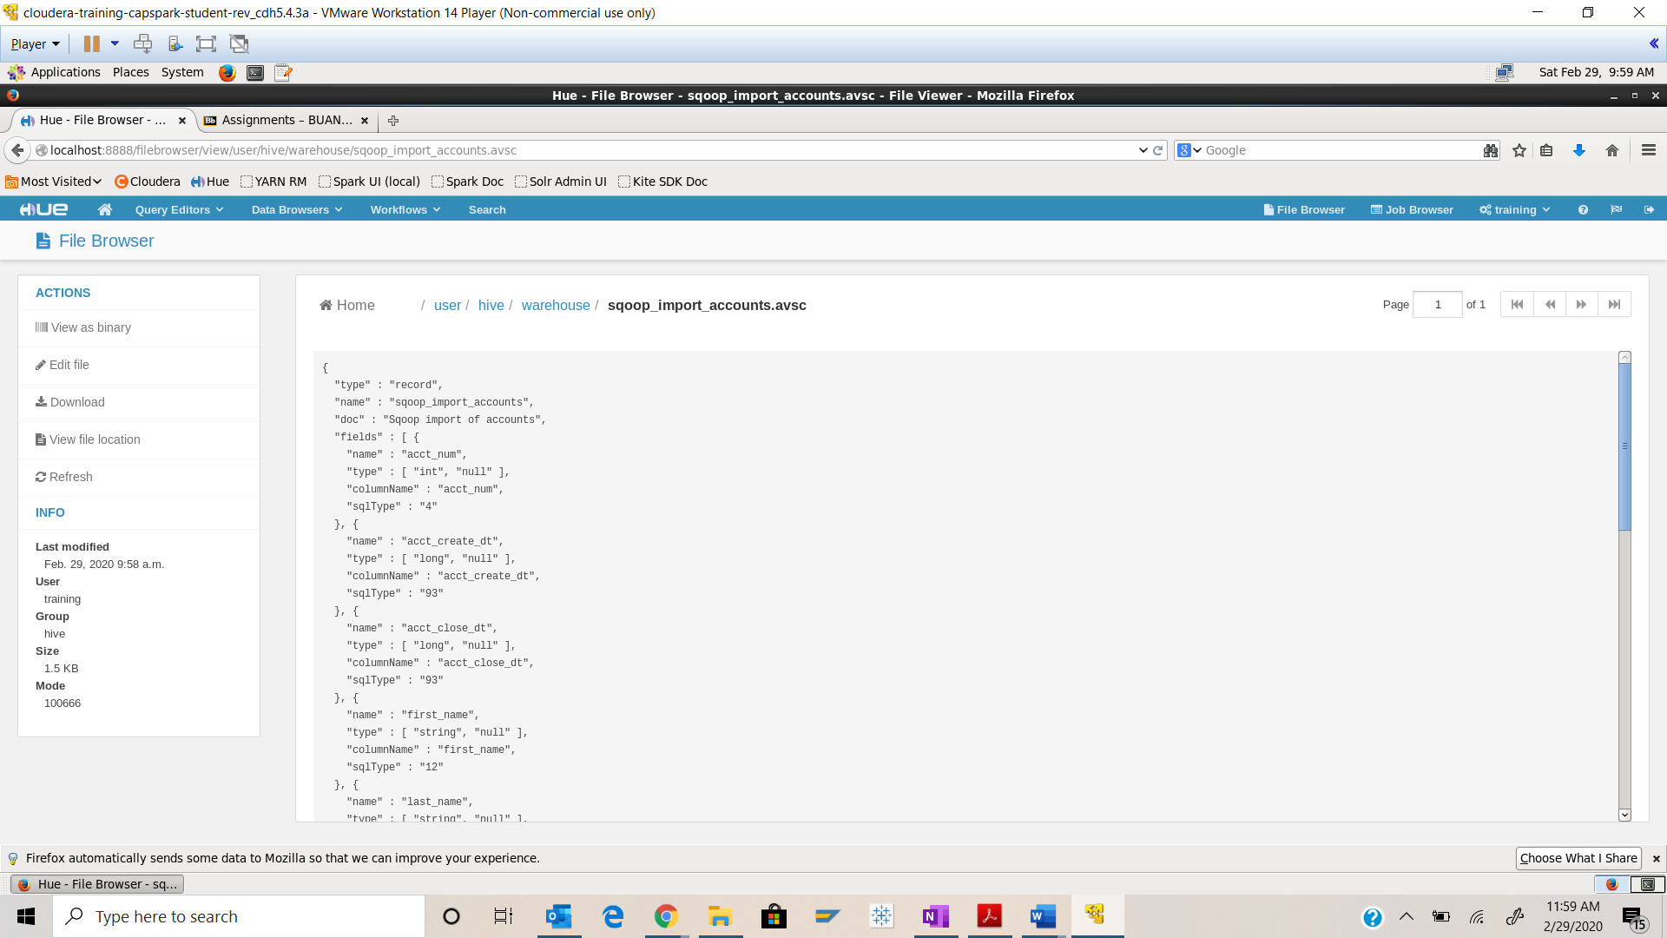



Step-8: Execute the following command at the shell prompt:



Q. Take a screenshot of the Beeline shell and paste it below.

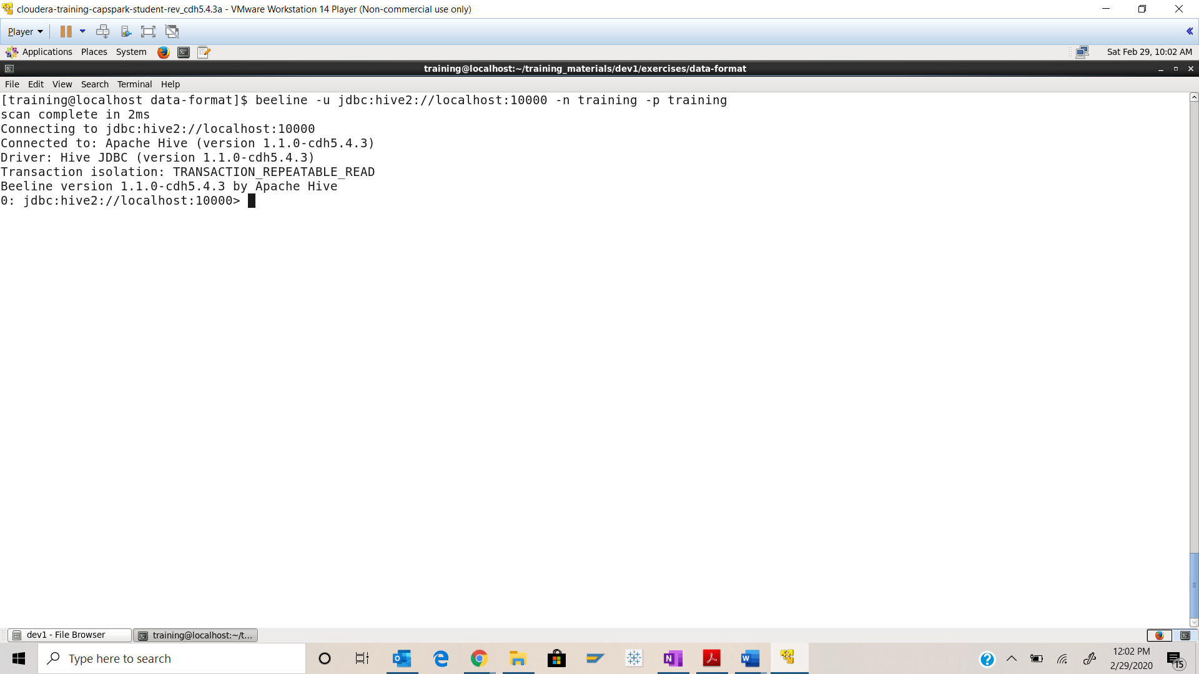

Step-9: Execute the following command at the beeline shell: 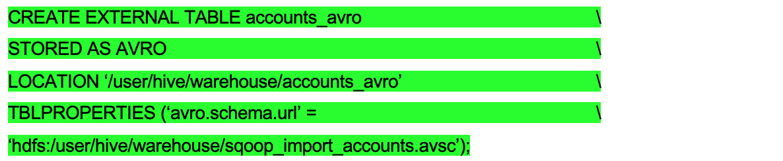

Q. Open the Hive Query Editor and click on the refresh button in the database panel, then click on the ‘Preview Sample Data’ button next to the accounts_avro table. Take a screenshot of the sample data and paste it below.

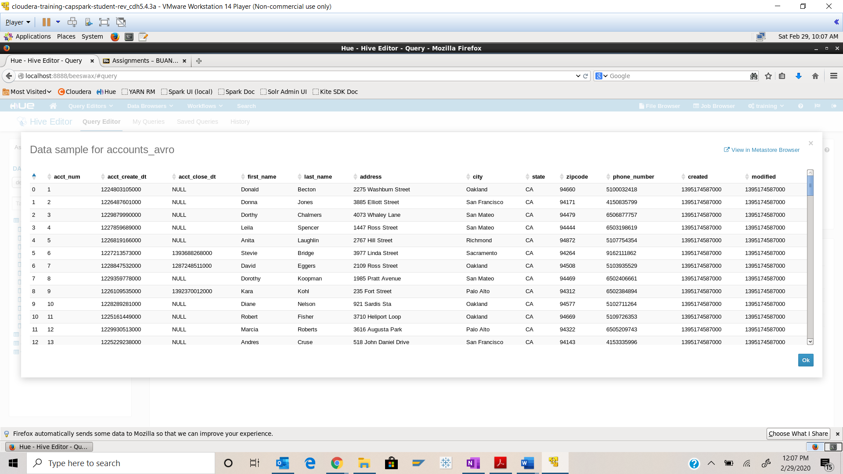

Step-10: Execute the following query at the beeline shell:

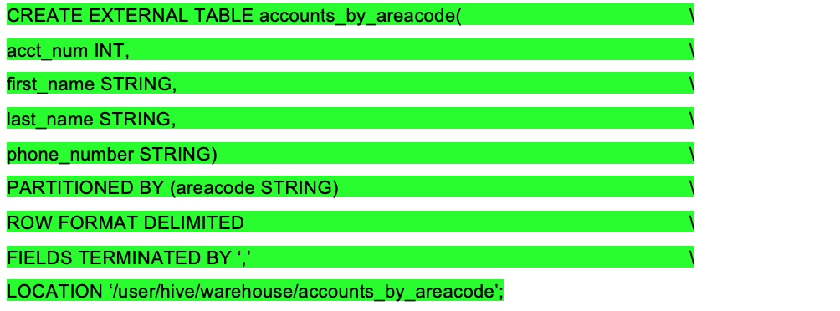

Q. Switch back to the Hive Query editor page and click on the refresh button in the database panel, and click on the

accounts_by_areacode table. Take a screenshot of this screen and highlight the schema for the table.

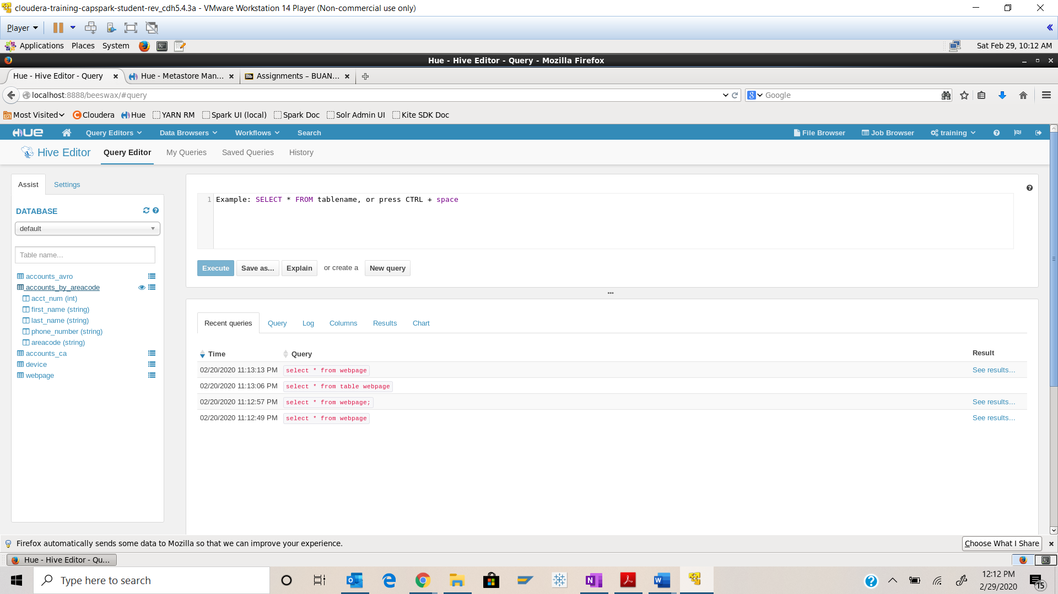



Step-11: Click on the ‘Preview Sample Data’ button next to the accounts_by_areacode table.

Q. Take a screenshot of data sample and paste it below. Why do we not see any data in this table?

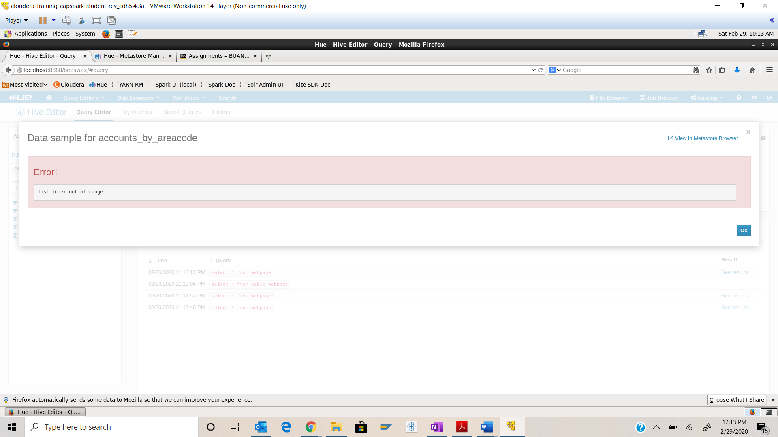

Since there is no data for AREACODE, we do not see anything here

Step-12: Execute the following query in the beeline:

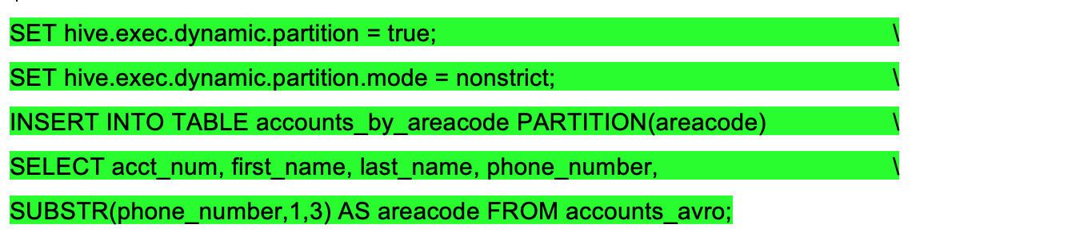

Q. Switch back to Hive Query editor and click on the ‘Preview Sample Data’ button next to the accounts_by_areacode table. Take a screenshot of the data sample and paste it below.

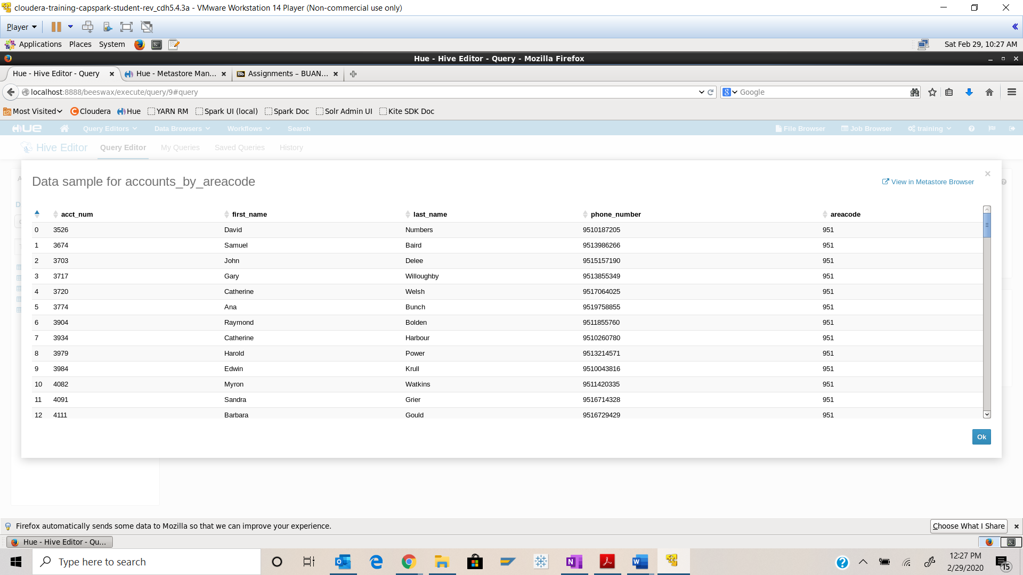

Step-13: Using the File Browser in HUE, navigate to the following directory /user/hive/warehouse/accounts_by_areacode

Q. Take a screenshot of the contents of the directory and paste it below.

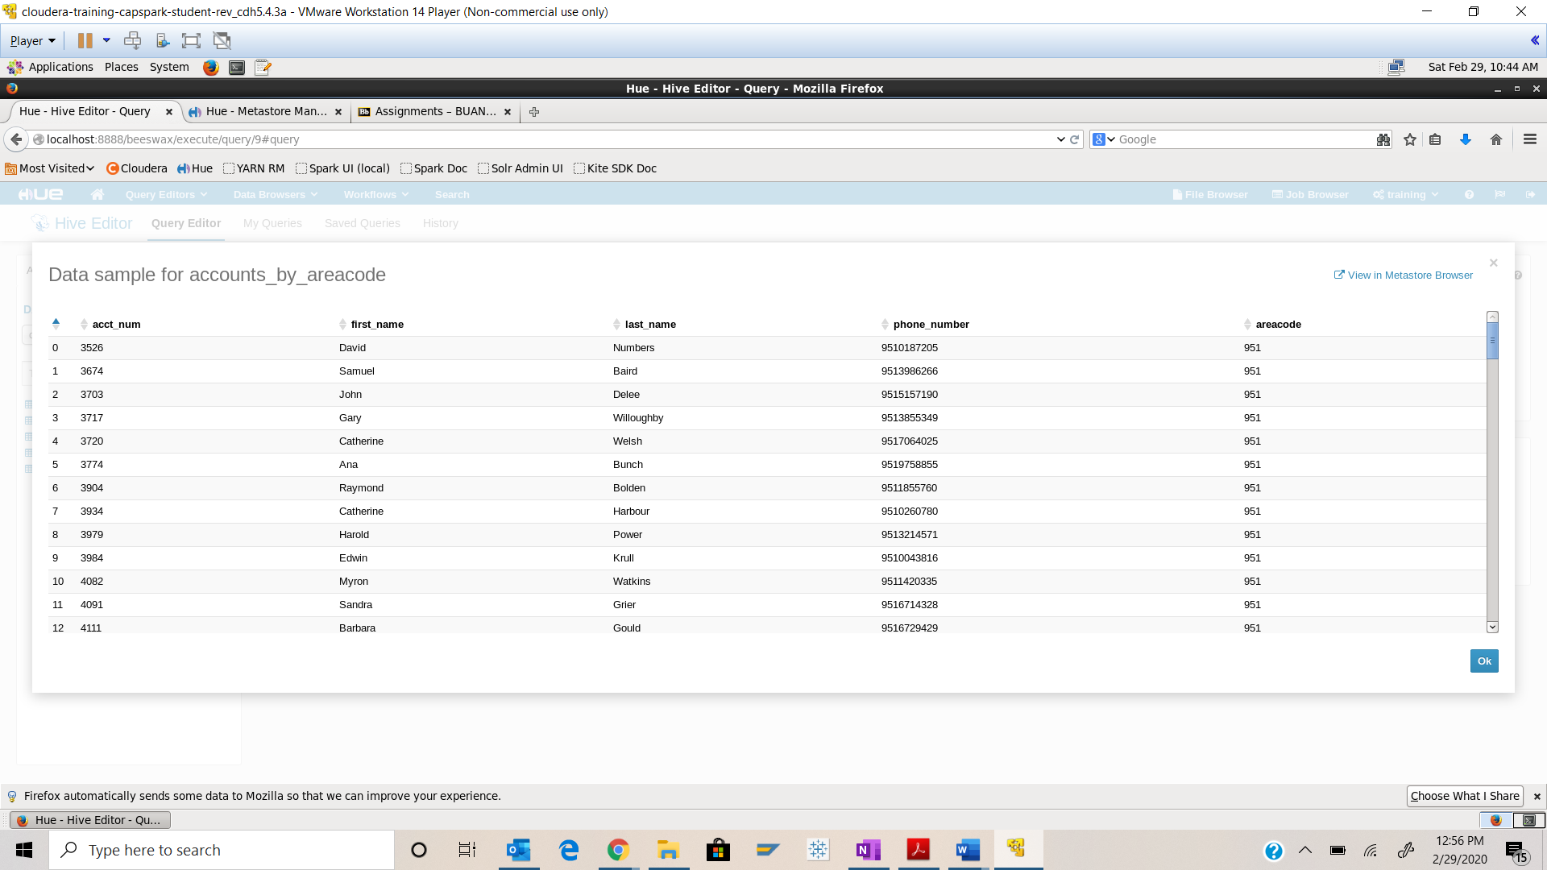

Part-3: Finding Help: This section will cover how to get additional information about Hive.

Step-14: The following link also provides additional documentation about Hive Query Language (HQL)

https://cwiki.apache.org/confluence/display/Hive/LanguageManual+Types#LanguageManualTypes-Overview

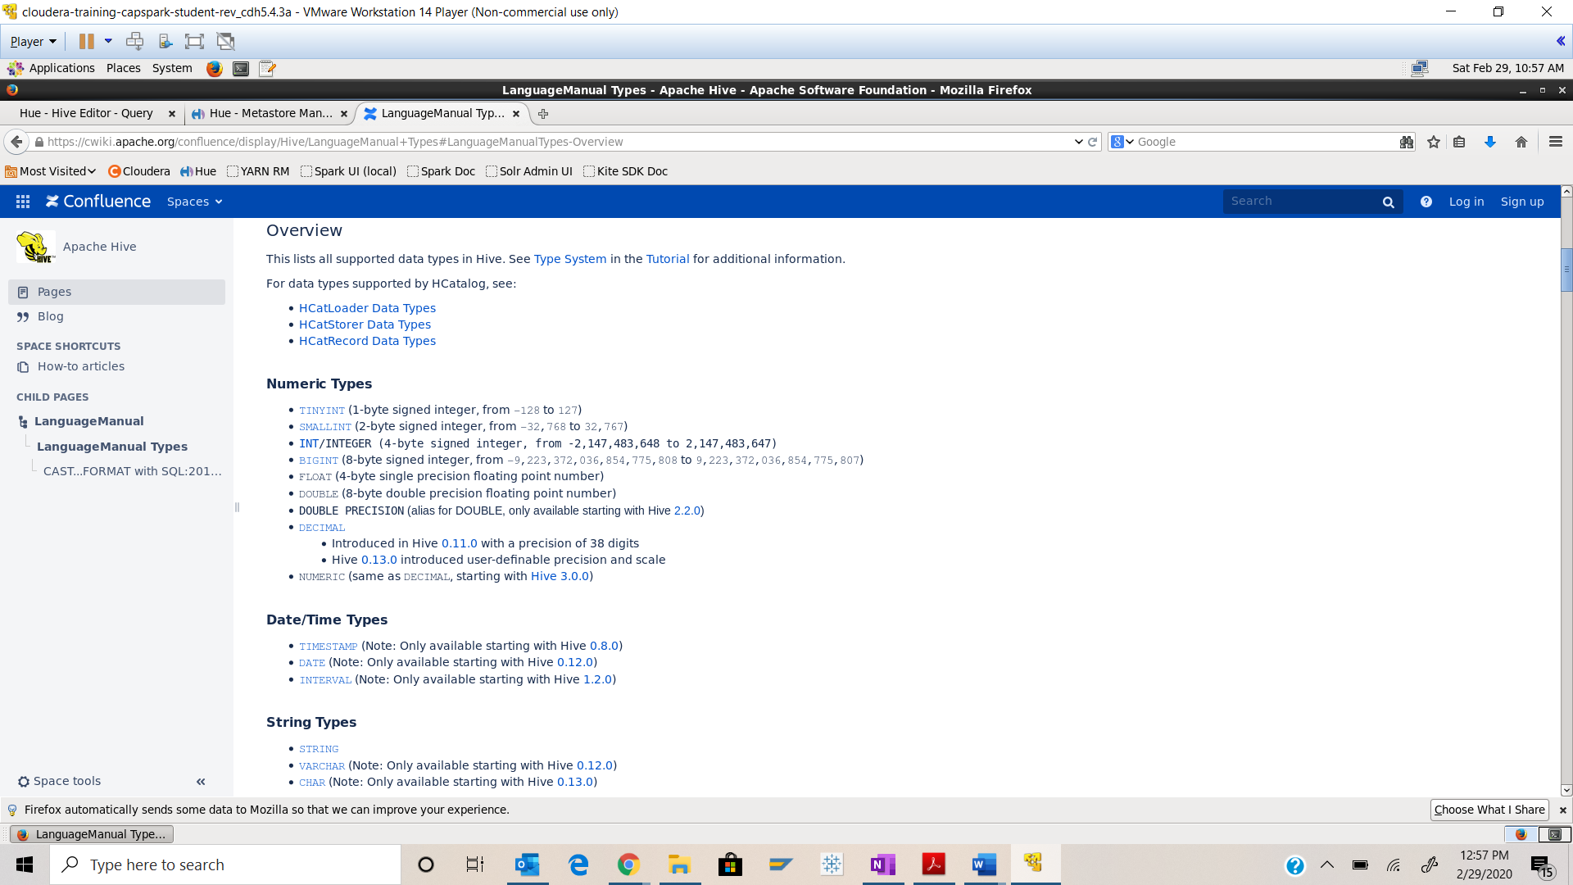

Step-15: Download the Checksum.zip file from eLearning in to the downloads folder **IN** the Cloudera VM using Mozilla Firefox.

Step-16: Execute the following command:



Q. Now type the command and execute. Take a screenshot of the shell output, highlight the zip file and paste it below.

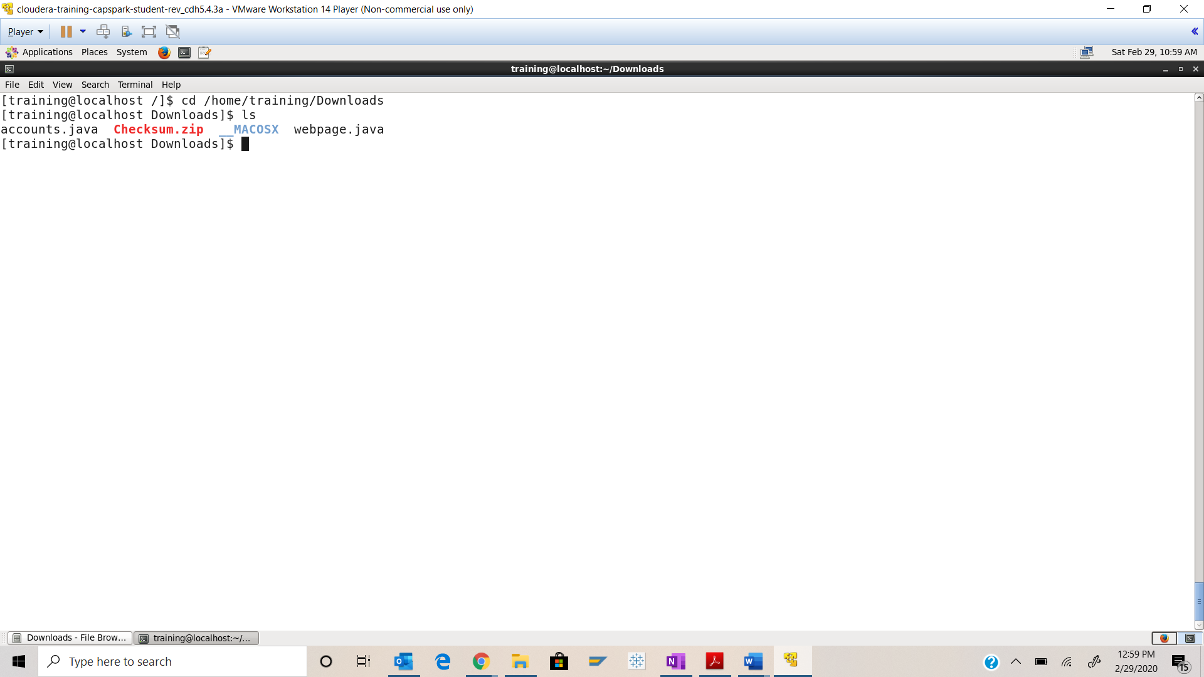



Step-17: Execute the following command at the shell prompt:



Q. Now type the command and execute. Take a screenshot of the shell output, highlight the contents of the zip file and paste it below.

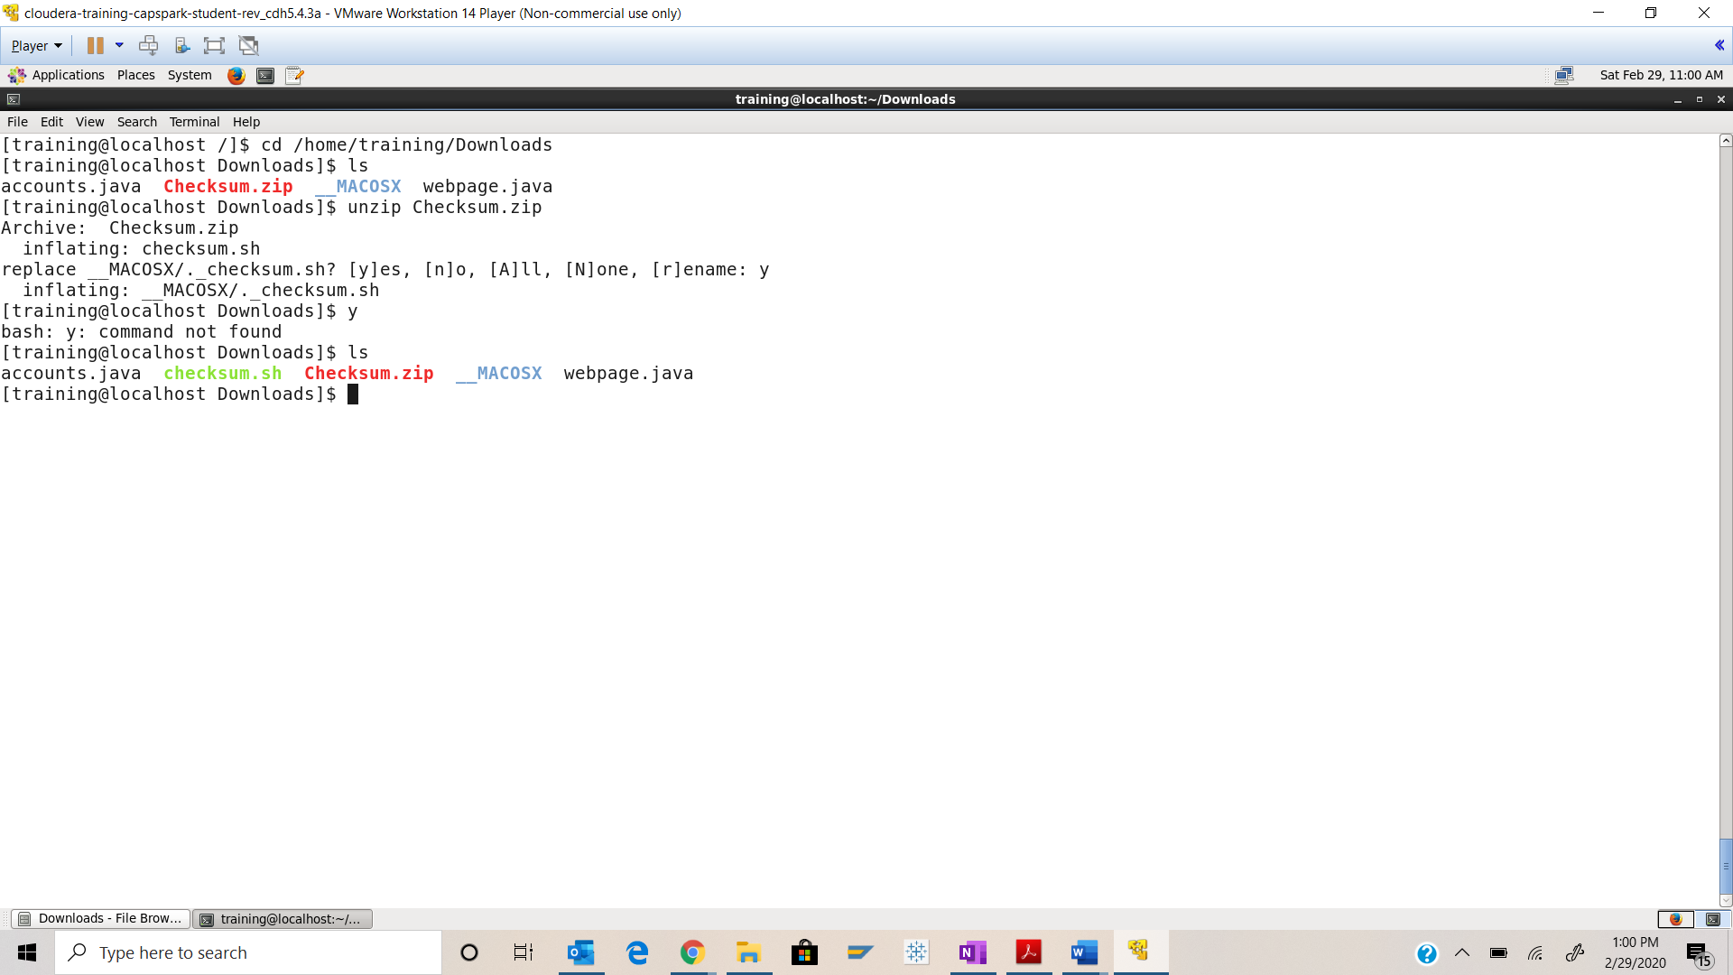



Step-18: Execute the following command at the shell prompt:

Then execute the following command:

Q. Take a screenshot of the shell output and paste it below.

Checksum value - 5bf08fc9fcbbea26419511fa2001fef4

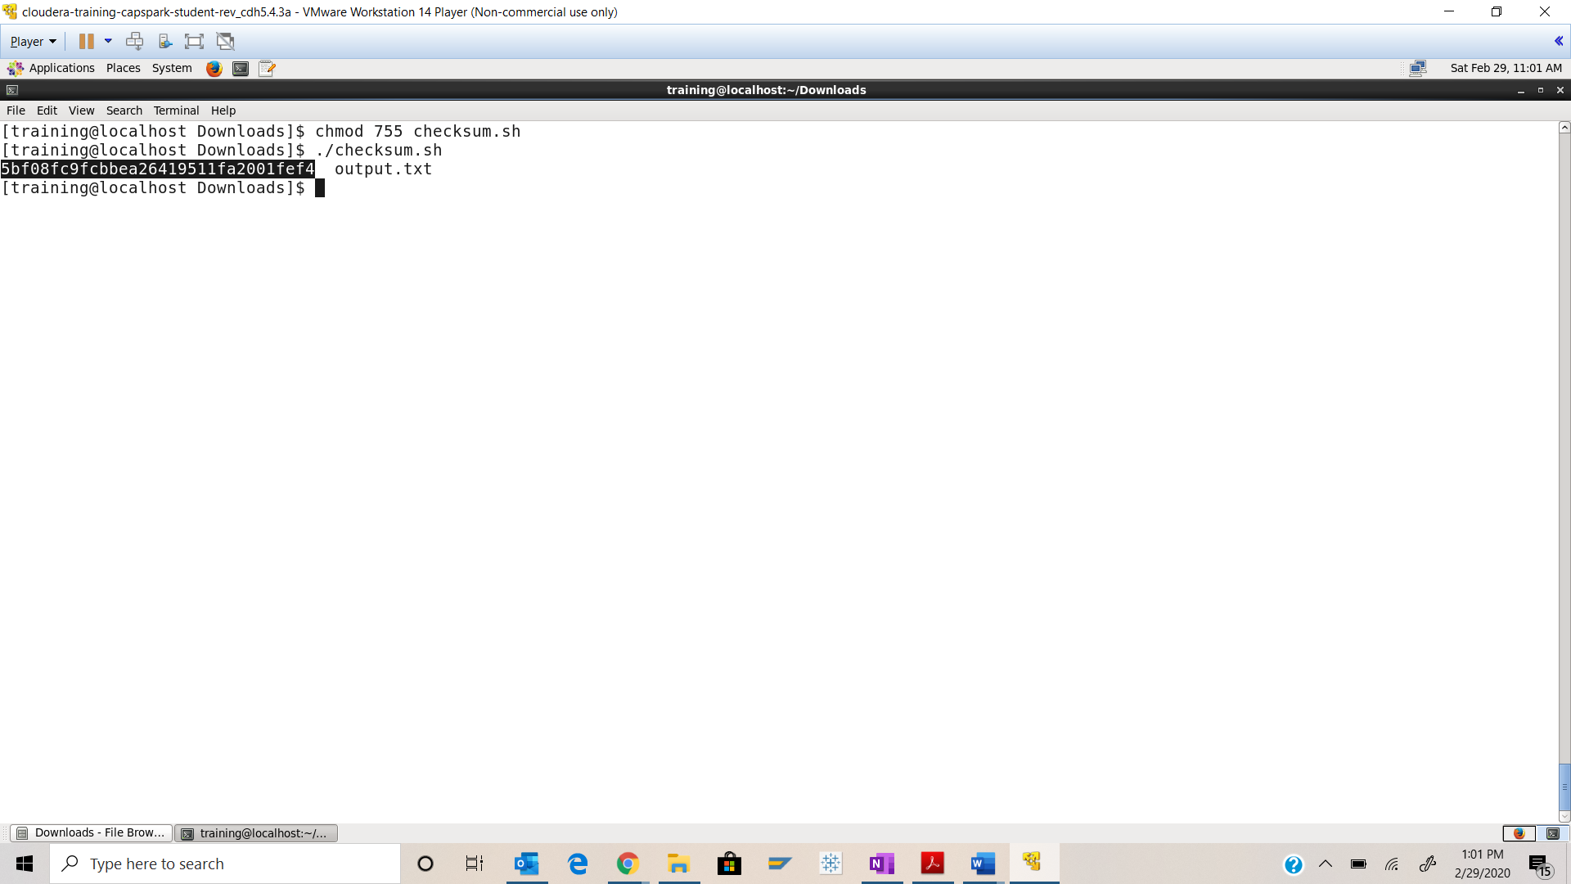

Step-19: Execute the following command at the shell prompt:

rm Checksum.zip checksum.sh output.txt



Q. Now type the command and execute. Take a screenshot of the shell output and paste it below.

